x


J.B.S.P SANSTHA’S CHANGU KANA THAKUR
ARTS, COMMERCE, SCIENCE COLLEGE
NEW PANVEL(AUTONOMOUS)

DEVELOPED BY
AMISHA DILIP KURANKAR

UNDER THE GUIDANCE OF
MR.AAKIF SHAIKH

ACADEMIC YEAR 2025-2026

TOPIC NAME: IMAGE CAPTIONING
ROLL NO: 41

SEAT NO:CS25649

CERTIFICATE

This is to certify that the project proposal Entitled

“IMAGE CAPTIONING”

Is successfully completed by Ms. Amisha Dilip Kurankar , Roll No: 41,Examination No:CS25649 under the guidance of Mr. Aakif Shaikh during the academic period of 30th June 2025 to 20th September 2025 as per the syllabus, fulfilment for the completion of the B.Sc (Semester – V) degree in the Computer Science at Changu Kana Thakur Arts, Commerce, and Science College New Panvel (Autonomous), University of Mumbai. It is also to certify that this is originalwork of the candidate done during the academic year 2025-2026.

Place: New Panvel

Date:

Project Guide | Head of Department
External Examiner | Principal

ACKNOWLEDGMENT

I would like to express my sincere gratitude to the Principal Prof.Dr.(Mr)
S.K.Patil of CKT ACS College and our Head of Department Dr. (Mrs.) S.A.Kamble and my guide too Mr. Aakif Shaikh for your invaluable course of the project.
I would like to thank you for your valuable guidance and appreciation for giving form and substance to this report. It is due to your enduring efforts, patients and enthusiasm, which has given a sense of direction and purpose fullness to this project and ultimately made it a success.
A sincere quote of thanks for providing me with all the information that I needed for this project, without which the successful completion of the project may not have been possible. We also appreciate the outstanding co-operation by the non- teaching staff, for the long timings that I could receive.
We are also very much thankful to the “Changu Kana Thakur Arts, Commerce And Science College” for including the project work as a part of the syllabus, without which we would not have gained the experience of using the analytical software as this.

Table of Contents

SR.  NO. | TITLE | PAGE NO.
1 | INTRODUCTION | 5
2 | IMPLEMENTATION DETAILS | 8
3 | SYSTEM REQUIREMENTS | 10
4 | OVERVIEW OF IMAGE CAPTIONING | 11
5 | METHODOLOGY | 12
5 | PROJECT IMPLEMENTATION | 14
6 | RESULT AND ANALYSIS | 19
7 | CONCLUSION | 22
8 | FUTURE ENHANCEMENT | 23
9 | PLAGIARISM | 24
10 | PROGRAM CODE | 25
11 | REFERENCES | 29

ABSTRACT

Image captioning is a challenging task in computer vision and natural language processing that involves generating descriptive textual captions for images automatically. This project implements an image captioning system using deep learning techniques, specifically leveraging the BLIP (Bootstrapping Language-Image Pre-training) model. The system can generate meaningful captions for input images with options to customize caption length and generation parameters. The implementation includes a user-friendly web interface built with Streamlit, allowing users to upload images, generate captions, and analyze the results through various visualization tools. The system demonstrates the practical application of transformer-based models in bridging the gap between visual content and natural language description, with potential applications in accessibility tools, content management and automated media description.

INTRODUCTION

Image captioning represents a significant advancement in machine learning, combining computer vision and natural language processing to understand visual content and describe it in human-readable text. This technology has gained substantial importance in recent years due to its wide range of applications, including assistance for visually impaired individuals, content-based image retrieval, automatic video subtitling, and social media content management.
The fundamental challenge in image captioning lies in developing models that can not only recognize objects in images but also understand their relationships, context, and attributes to generate coherent and relevant descriptions. Traditional approaches to this problem involved separate computer vision models for image understanding and natural language generation models for caption production. However, recent advancements in deep learning, particularly with transformer architectures, have enabled end-to-end solutions that jointly learn visual and linguistic representations.
The emergence of pre-trained multimodal models like BLIP has revolutionized image captioning by providing robust foundation models that can be fine-tuned for specific tasks. These models are trained on massive datasets containing image-text pairs, allowing them to learn rich representations that bridge the visual and textual domains.
This project explores the implementation of an image captioning system using the BLIP architecture, providing a practical application of state-of-the-art deep learning techniques for generating descriptive captions for images. The system includes features for customizing caption generation parameters and analyzing the results through various visualization tools.
What is Image Captioning?
Image captioning is a machine learning task that involves generating a textual description of an image's content. Unlike image classification, which assigns labels to images, or object detection, which identifies and locates objects within images, captioning requires understanding the scene as a whole and expressing it in natural language.

A successful image captioning system must:
- Identify objects and their attributes in the image
- Understand the relationships between objects
- Recognize the context and scene type
- Generate grammatically correct and semantically meaningful descriptions

Applications of Image Captioning
Image captioning technology has numerous practical applications:
- Accessibility: Providing descriptions of images for visually impaired users
- Content Management: Automatically tagging and organizing large image collections
- Education: Generating descriptions for educational materials
- Social media: Automatically suggesting captions for uploaded images
- Surveillance: Describing activities in security footage
- E-commerce: Generating product descriptions from images
IMPLEMENTATION DETAILS

TRANSFORMER ARCHITECTURE
The transformer architecture has become the foundation for many state-of-the-art models in natural language processing and multimodal learning. Unlike recurrent neural networks, transformers use self-attention mechanisms to process input sequences in parallel, making them more efficient and capable of capturing long-range dependencies.
In image captioning, transformer-based models can effectively combine visual features from images with textual information to generate captions. The attention mechanism allows the model to focus on different parts of the image when generating each word of the caption, resulting in more accurate and contextually relevant descriptions.

BLIP MODEL
BLIP (Bootstrapping Language-Image Pre-training) is a state-of-the-art vision-language pre-training framework that effectively utilizes noisy web data by bootstrapping the captions. It achieves state-of-the-art results on a wide range of vision-language tasks, including image captioning.
Key features of BLIP include:
- A multimodal mixture of encoder-decoder models
- Capability to understand and generate language based on visual inputs
- Effective handling of noisy web data through caption bootstrapping
- Strong performance on both understanding-based and generation-based tasks
The BLIP model used in this project is pre-trained on large-scale image-text pairs and can generate high-quality captions for a wide variety of images without requiring task-specific fine-tuning.

STREAMLIT
Streamlit is an open-source Python framework that allows developers to create web applications for data science and machine learning projects quickly. It provides interactive components and easy integration with popular data science libraries, making it ideal for building interactive demos of machine learning models.
In this project, Streamlit is used to create a user-friendly interface for the image captioning system, allowing users to upload images, adjust generation parameters, view results, and analyze caption statistics through interactive visualizations.

Libraries Used
- streamlit → For building the interactive web app (UI, file uploader, sidebar, plots, etc.).
- PIL (Pillow) → For image handling (Image.open, convert to RGB).
- torch (PyTorch) → For deep learning inference and GPU acceleration.
- transformers (Hugging Face) → For loading the BLIP processor and model (BlipProcessor, BlipForConditionalGeneration).
- io → For handling text data as downloadable files (BytesIO).
- matplotlib → For plotting graphs (caption length vs beam size, histograms, etc.).
- pandas → For handling caption datasets (captions_dataset.csv).
- collections.Counter → For word frequency analysis in generated captions.

Models Used
Your app supports two pretrained BLIP models from Hugging Face:
- Salesforce/blip-image-captioning-base o A smaller BLIP model, faster but less accurate.
- Salesforce/blip-image-captioning-large o A larger BLIP model, more accurate but slower and heavier.
These models are vision–language transformers that take an image as input and directly generate captions.

Summary
- Frameworks/Libraries:
streamlit, PIL, torch, transformers, io, matplotlib, pandas, collections.Counter
- Models:
o Salesforce/blip-image-captioning-base o Salesforce/blip-image-captioning-large

SYSTEM REQUIREMENTS

Hardware details

Component Specification

Processor Intel Core i5 7th Generation or higher

RAM 8 GB or higher

Storage 200 GB HDD or SSD

Graphics GPU with CUDA support (optional)

ACCESSORIE
Web Cam, Keyboard & Mouse S

Software details
Component | Specification
Operating System | Windows 10/11, Linux, or macOS
Programming Language | Python 3.8+
Libraries | Streamlit, BlipProcessor, Transformers, PIL,matplotlib,torch

OVERVIEW ON IMAGE CAPTIONING

Overview on Image Captioning
Traditionally, image captioning relied on template-based methods, where predefined sentence structures were filled with detected objects. While effective for simple descriptions, these methods had limitations in handling complex scenes and generating natural language sentences.
Modern approaches, such as BLIP (Bootstrapping Language-Image Pre-training), use transformer-based architectures that jointly learn vision and language. This enables the system to generate more natural, human-like captions without relying on handcrafted templates or separate feature extractors.

Image Captioning Process
The process typically involves several stages:
- Preprocessing – The input image is resized and converted into a format suitable for the model.
- Caption Generation – BLIP directly takes the image as input and, through its vision–language transformer, generates a descriptive caption.
- Post-processing – Refinement steps ensure the sentence is grammatically correct and fluent.

Block Diagram of Image Captioning Model
Training Phase
- The model is trained on paired image–caption datasets.
- BLIP learns to align visual content with textual descriptions using its vision–language pretraining.
Testing/Deployment Phase
- A new image is given as input.
- The trained BLIP model automatically generates a descriptive caption.

Proposed Image Captioning System Architecture
Our system is based on BLIP with Hugging Face Transformers and PyTorch. The workflow consists of:
- Training (or using pretrained BLIP) – The model is pretrained on large-scale image–text pairs. Fine-tuning can be applied if needed.
- Caption Generation – The model processes new input images and generates natural captions that describe their content.

Real-Time Image Caption Generation
The system can be applied to real-time image streams. For instance, a camera feed can be passed to BLIP, which then produces descriptive captions dynamically.

System Workflow
Training Phase (if fine-tuned)
- Load training images with captions.
- Train BLIP on these pairs.
- Save the trained model.
Deployment Phase
- Load a new image.
- Pass it through BLIP.
- Generate a caption.
- Display the output.

METHODOLOGY

Methodology for Image Captioning
The methodology of the Image Captioning project is structured into model loading, image preprocessing, caption generation, visualization, and analysis. Below are the detailed steps:

1. Model Loading
- The system uses the BLIP (Bootstrapping Language-Image Pretraining) model from HuggingFace Transformers.
- A function load_model() loads the selected BLIP model (base or large) and its processor.
- Streamlit’s @st.cache_resource ensures that the model is cached and does not reload repeatedly, improving efficiency.

2. User Input (Image Upload & Settings)
- Users upload an image (.jpg, .jpeg, .png) through the file uploader.
- Sidebar options let users configure:
  - Minimum Caption Length o Maximum Caption Length
  - Beam Search Size (controls caption diversity and quality)

3. Preprocessing
- The uploaded image is converted to RGB format and passed to the BLIP processor.
- The processor prepares the image into tensor format required by the model.
- The data is moved to GPU (if available) for faster computation.

4. Caption Generation
- The BLIP model’s generate() function is used to create captions.
- Important parameters:
  - Beam Search (num_beams): explores multiple caption candidates.
  - min_length / max_length: ensures captions are within user-defined limits.
  - early_stopping: stops generation once an end token is reached.
- The generated tokens are decoded into human-readable text.
- The caption is displayed along with its word length.

5. Post-Processing & User Options
- Length Checks: Warns if the generated caption is shorter or longer than user settings.
- Download Option: Captions can be downloaded as .txt.
- Save Option: Captions and corresponding image names can be stored in a CSV (captions_dataset.csv).

6. Graphs & Analysis
The app includes three visualization features for deeper understanding:
- Caption Length vs Beam Size o Captions are generated with different beam sizes.
  - A line graph shows how caption length changes with beam search.
- Word Frequency in Current Caption o Tokenizes the generated caption. o Counts word occurrences using Counter.
  - Displays a bar graph of the most frequent words.

3. Dataset Caption Length Distribution
- If a dataset exists (captions_dataset.csv), it calculates caption lengths for all stored samples.
- Displays a histogram showing the distribution of caption lengths across the dataset.

7. Deployment Phase
- The trained BLIP model is integrated directly via HuggingFace.
- The app is deployed as an interactive Streamlit web application.
- End-users can upload images, generate captions, analyze results, and save data without needing coding knowledge.
Project Implementation
Code:
- Environment Setup
  - Programming Language: Python 3.9+ ● Libraries used:
    - Streamlit → for building the web interface o Torch (PyTorch) → for running BLIP model o Transformers (HuggingFace) → for BLIP model and processor o PIL → for handling uploaded images o Matplotlib & Pandas → for graphs and analysis o Collections (Counter) → for word frequency analysis

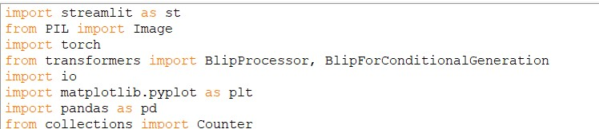

- Model Integration
  - The system uses BLIP (Bootstrapping Language-Image Pretraining) from HuggingFace.
  - Users can choose between:
    - Salesforce/blip-image-captioning-base o Salesforce/blip-image-captioning-large
  - The model is loaded once using @st.cache_resource for efficiency.
  - It automatically runs on GPU (CUDA) if available, else falls back to CPU.
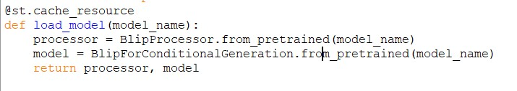

- User Interaction
  - Users upload an image via the file uploader (supports .jpg, .jpeg, .png).
  - Sidebar provides customizable settings:
    - Minimum and Maximum Caption Length
    - Beam Search Size (controls caption diversity and accuracy)
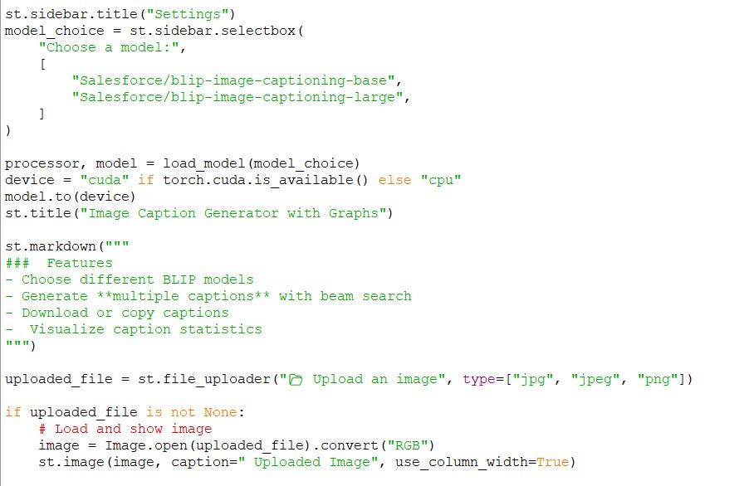
4.
Caption Generation
  - Uploaded image is preprocessed with BLIPProcessor.
  - The generated token sequence is decoded into a natural language caption.
  - Caption length (number of words) is calculated.
  - Warnings are shown if caption length does not match the user’s desired range.

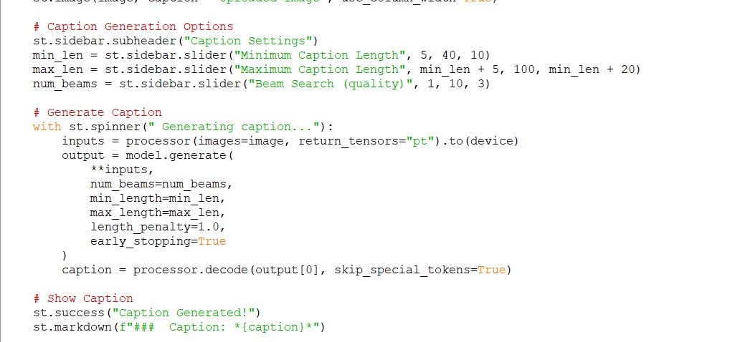

5. Post-Processing
- Caption can be downloaded as a .txt file.
- Option to save results (image name + caption) into captions_dataset.csv.
- This dataset grows dynamically as more captions are generated.
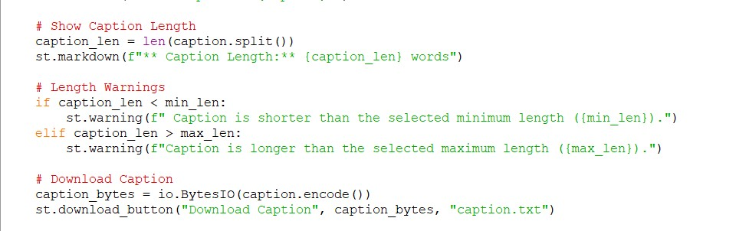
6.
Visualization & Graphs
Three types of graphs are implemented:
- Caption Length vs Beam Size o Multiple captions are generated with increasing beam size.
  - A line plot shows how caption length changes with beam search settings.
- Word Frequency in Current Caption o The generated caption is tokenized into words. o Word counts are computed using Counter.
  - A bar graph shows most frequently used words in the caption.
- Distribution of Caption Lengths (Dataset Level)
  - If captions_dataset.csv exists, all saved captions are analyzed. o Caption lengths are calculated and plotted as a histogram.
  - Shows the spread of caption lengths across previously generated captions.

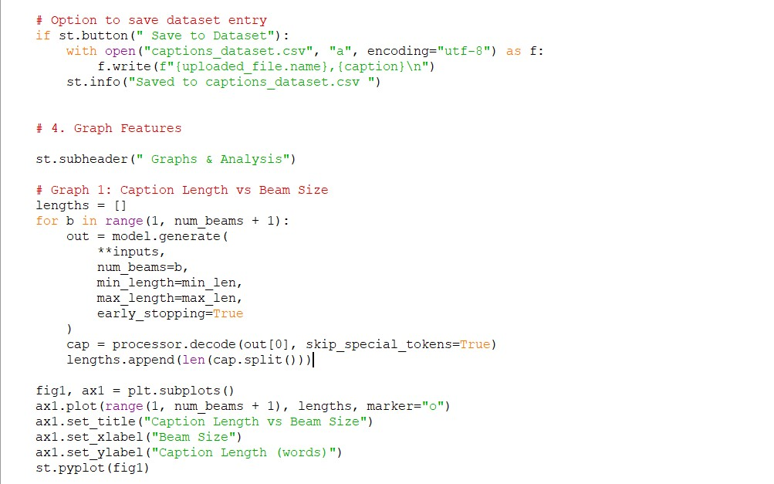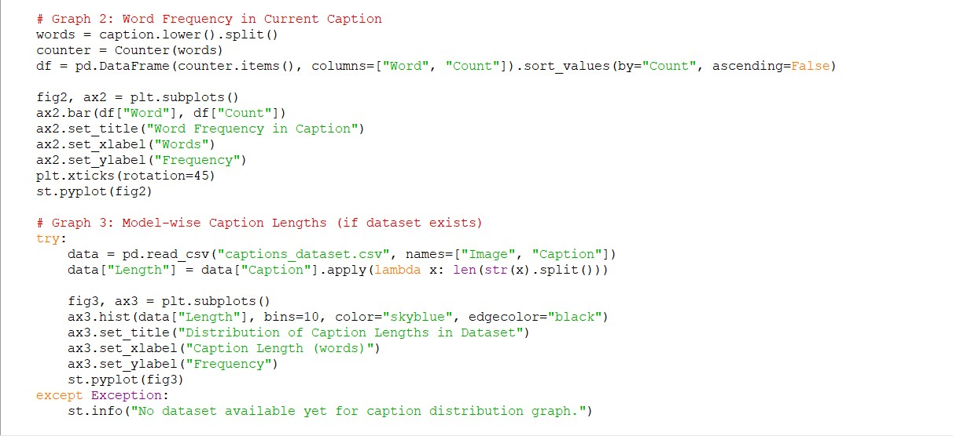

7. Deployment
- The project is deployed as a Streamlit app.
- End-users interact with the system through a browser interface.
- The app provides:
- Real-time caption generation
- Downloadable results o Statistical insights via graphs
Result and Analysis
Output:This is the final output page ,where an user can upload any image and get its caption.
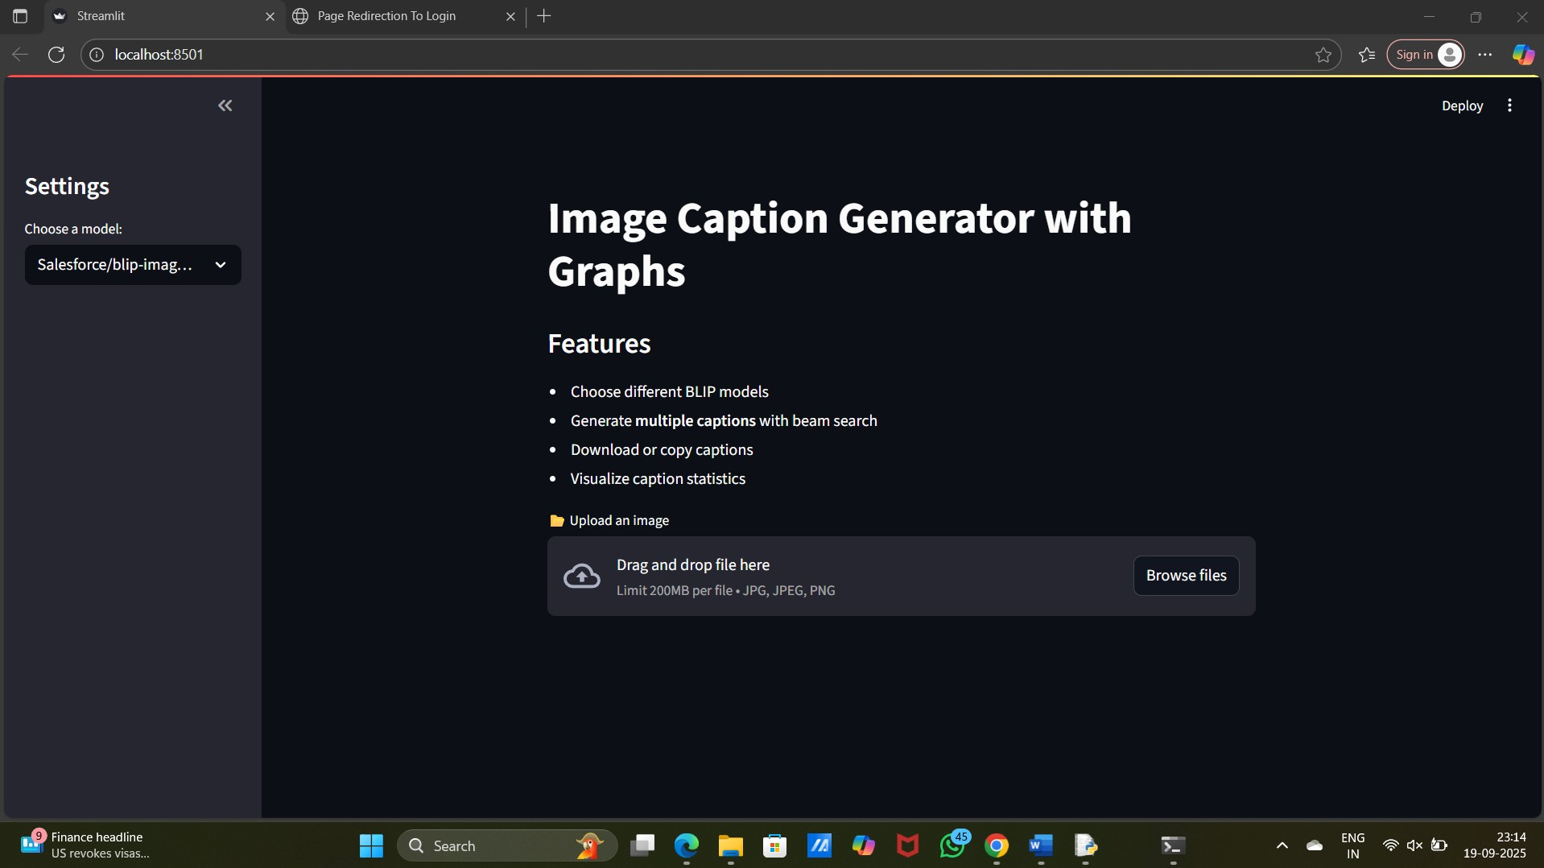

Output: After Inserting an image it creates a descriptive caption.We can also manage the length of our caption,with correct graphs.
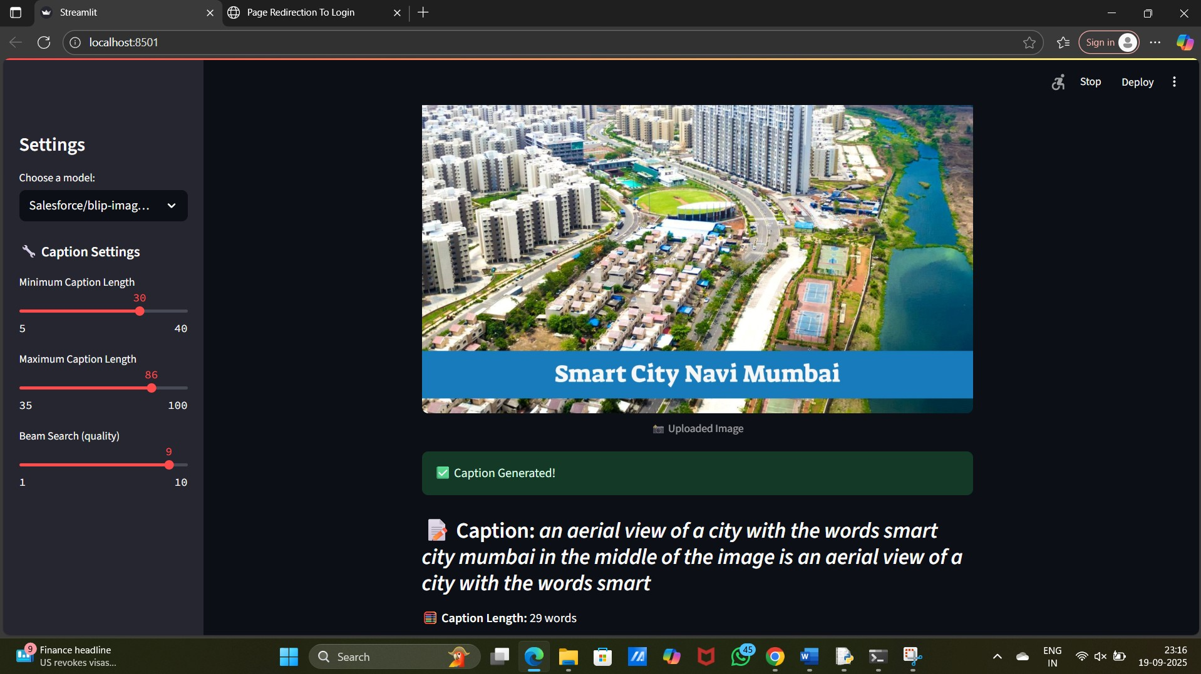

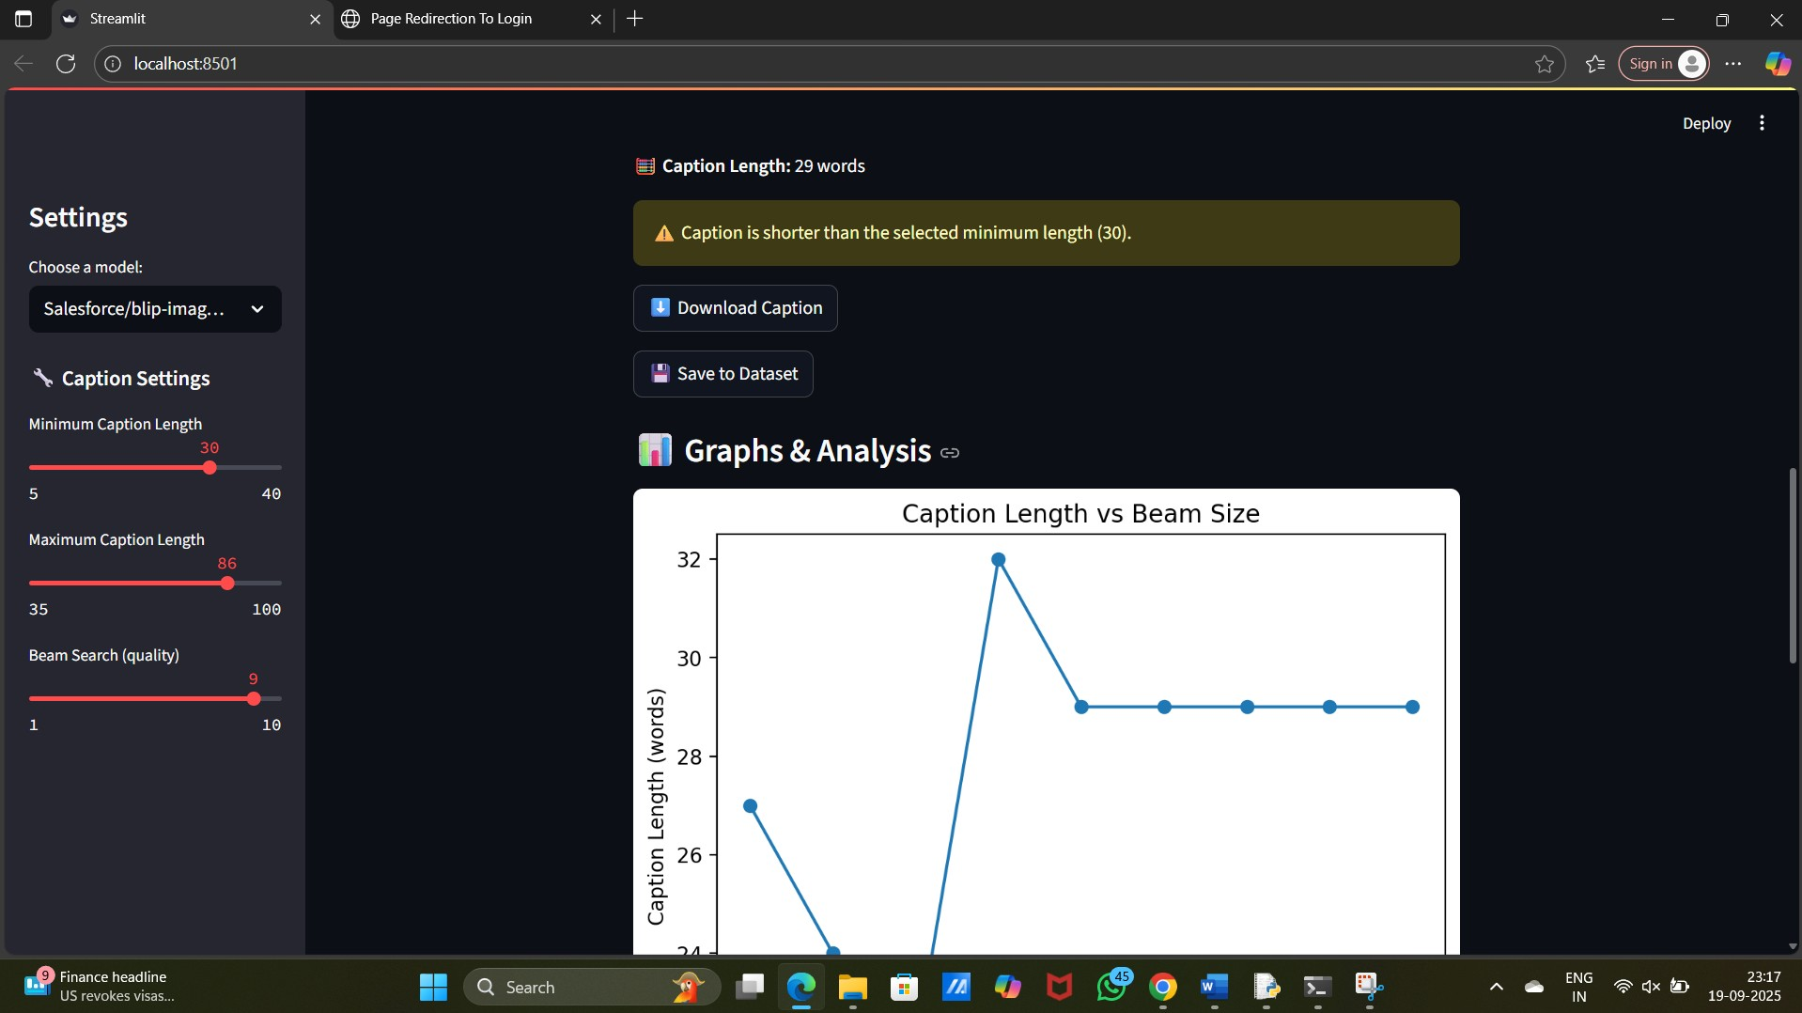
This graph shows the caption length and beam size

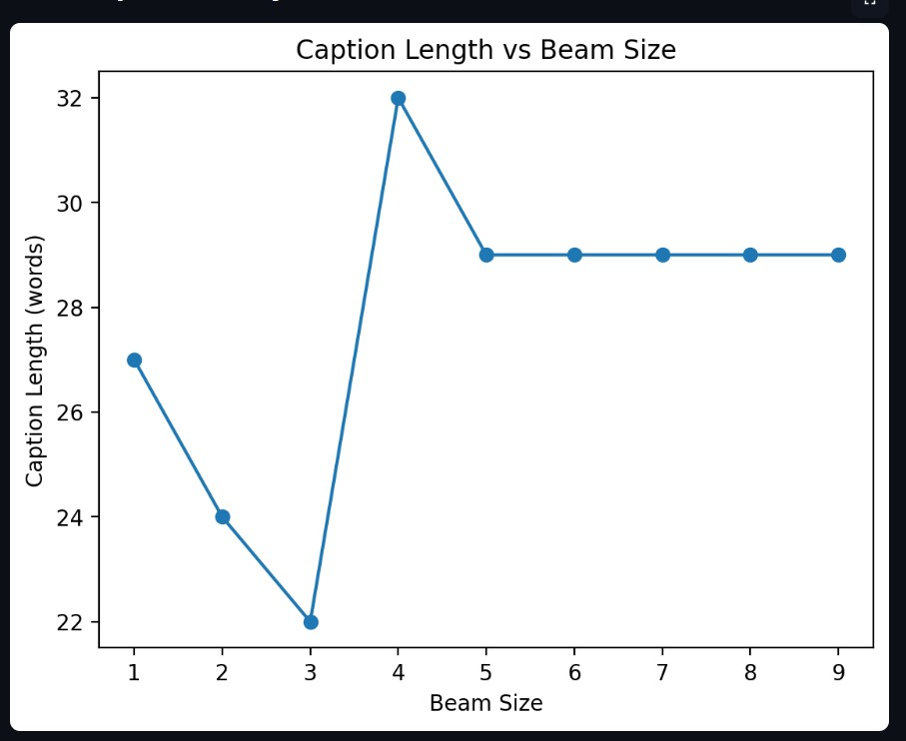
This graph shows the captions length and words frequency .

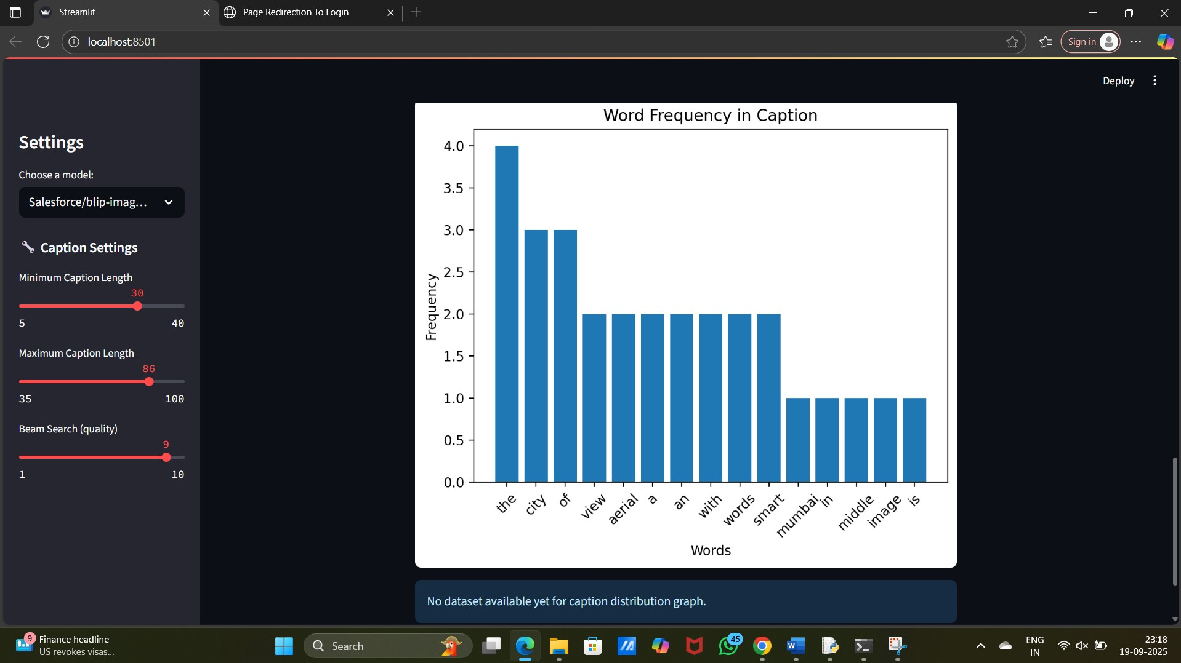

CONCLUSION

This project successfully implements an image captioning system using the BLIP model from Hugging Face Transformers. The system provides a user-friendly interface for generating descriptive captions for images, with options to customize generation parameters and analyze results through various visualizations.
The implementation demonstrates the practical application of state-of-the-art deep learning models for bridging computer vision and natural language processing. The BLIP model proves to be highly effective at generating relevant and coherent captions for a wide variety of images without requiring task-specific fine-tuning.
The system's interactive features, including parameter adjustment and visualization tools, provide valuable insights into the caption generation process and allow users to understand how different parameters affect the results.
Overall, this project showcases the capabilities of modern AI systems in understanding and describing visual content, with potential applications in accessibility, content management, and automated media description.

Future Enhancement

- Several improvements could enhance the image captioning system:
- Fine-tuning Capability: Allow users to fine-tune the model on custom datasets for domain-specific applications.
- Multiple Caption Generation: Generate several candidate captions for each image and allow users to select the most appropriate one.
- Caption Editing Interface: Provide tools for users to edit generated captions and use the corrections to improve the model.
- Multilingual Support: Extend the system to generate captions in multiple languages.
- Real-time Captioning: Implement real-time captioning for video streams or camera input.
- Advanced Analysis Tools: Add more sophisticated analysis features, such as sentiment analysis of captions or similarity comparison between images based on captions.
- API Integration: Create a REST API for the captioning service to allow integration with other applications.
- Batch Processing: Enable processing of multiple images simultaneously for efficiency.
- Custom Model Support: Allow users to upload and use their own trained models instead of the pre-trained BLIP models.
- Accessibility Features: Enhance the interface with screen reader compatibility and other accessibility features.
PLAGIARISM

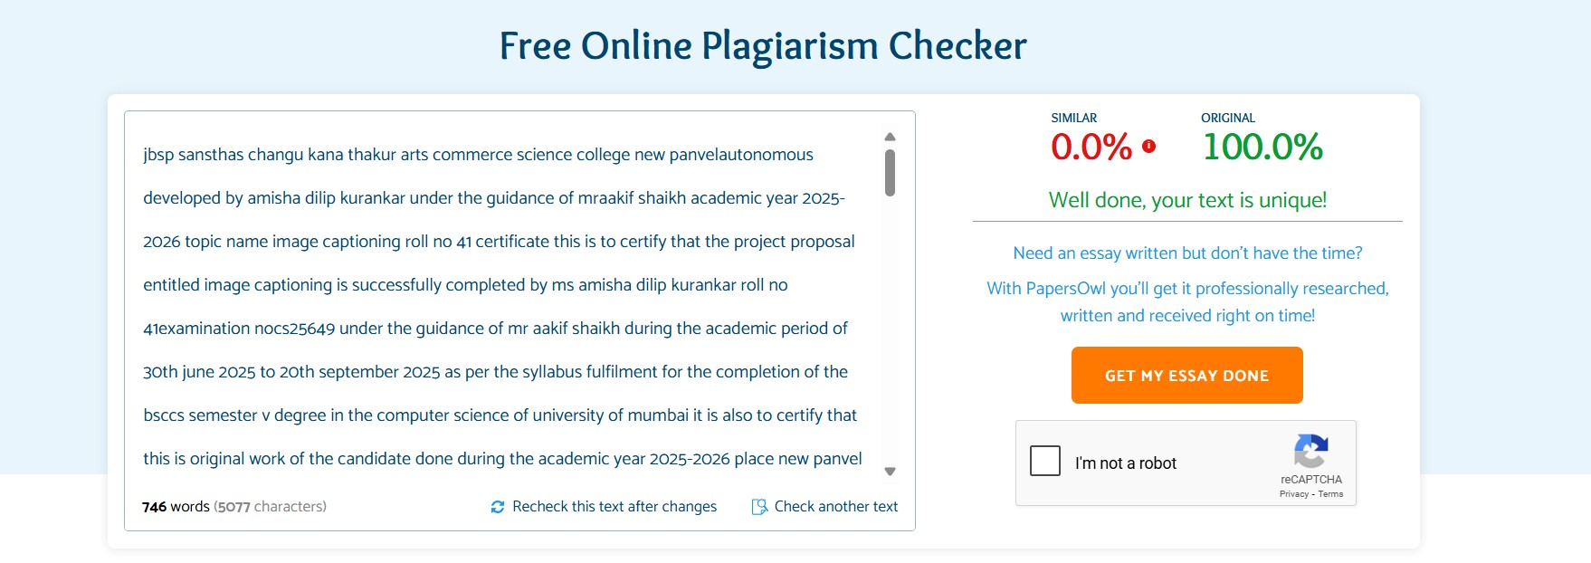
PROGRAM CODE CODE:
import streamlit as st from PIL import Image import torch from transformers import BlipProcessor, BlipForConditionalGeneration import io import matplotlib.pyplot as plt import pandas as pd from collections import Counter @st.cache_resource def load_model(model_name):
processor = BlipProcessor.from_pretrained(model_name) model = BlipForConditionalGeneration.from_pretrained(model_name) return processor, model

st.sidebar.title("Settings") model_choice = st.sidebar.selectbox(
"Choose a model:",
[
"Salesforce/blip-image-captioning-base",
"Salesforce/blip-image-captioning-large",
]
)

processor, model = load_model(model_choice) device = "cuda" if torch.cuda.is_available() else "cpu" model.to(device) st.title("Image Caption Generator with Graphs")

st.markdown("""
### Features
- Choose different BLIP models
- Generate **multiple captions** with beam search
- Download or copy captions
- Visualize caption statistics
""")

uploaded_file = st.file_uploader("Upload an image", type=["jpg", "jpeg", "png"])

if uploaded_file is not None: # Load and show image image = Image.open(uploaded_file).convert("RGB") st.image(image, caption=" Uploaded Image", use_column_width=True)

# Caption Generation Options st.sidebar.subheader("Caption Settings") min_len = st.sidebar.slider("Minimum Caption Length", 5, 40, 10) max_len = st.sidebar.slider("Maximum Caption Length", min_len + 5, 100, min_len + 20) num_beams = st.sidebar.slider("Beam Search (quality)", 1, 10, 3)

# Generate Caption with st.spinner(" Generating caption..."):
inputs = processor(images=image, return_tensors="pt").to(device) output = model.generate(
**inputs,
num_beams=num_beams, min_length=min_len, max_length=max_len, length_penalty=1.0, early_stopping=True
)
caption = processor.decode(output[0], skip_special_tokens=True)

# Show Caption st.success("Caption Generated!") st.markdown(f"### Caption: *{caption}*")

# Show Caption Length caption_len = len(caption.split()) st.markdown(f"** Caption Length:** {caption_len} words")

# Length Warnings if caption_len < min_len:
st.warning(f" Caption is shorter than the selected minimum length ({min_len}).") elif caption_len > max_len:
st.warning(f"Caption is longer than the selected maximum length ({max_len}).")

# Download Caption caption_bytes = io.BytesIO(caption.encode()) st.download_button("Download Caption", caption_bytes, "caption.txt")

# Option to save dataset entry if st.button(" Save to Dataset"): with open("captions_dataset.csv", "a", encoding="utf-8") as f: f.write(f"{uploaded_file.name},{caption}\n") st.info("Saved to captions_dataset.csv ")

# 4. Graph Features

st.subheader(" Graphs & Analysis")

# Graph 1: Caption Length vs Beam Size lengths = [] for b in range(1, num_beams + 1):
out = model.generate( **inputs, num_beams=b, min_length=min_len, max_length=max_len, early_stopping=True
)
cap = processor.decode(out[0], skip_special_tokens=True) lengths.append(len(cap.split()))

fig1, ax1 = plt.subplots() ax1.plot(range(1, num_beams + 1), lengths, marker="o") ax1.set_title("Caption Length vs Beam Size") ax1.set_xlabel("Beam Size") ax1.set_ylabel("Caption Length (words)") st.pyplot(fig1)

# Graph 2: Word Frequency in Current Caption words = caption.lower().split() counter = Counter(words)
df = pd.DataFrame(counter.items(), columns=["Word", "Count"]).sort_values(by="Count", ascending=False)

fig2, ax2 = plt.subplots() ax2.bar(df["Word"], df["Count"]) ax2.set_title("Word Frequency in Caption") ax2.set_xlabel("Words") ax2.set_ylabel("Frequency") plt.xticks(rotation=45) st.pyplot(fig2)

# Graph 3: Model-wise Caption Lengths (if dataset exists) try:
data = pd.read_csv("captions_dataset.csv", names=["Image", "Caption"]) data["Length"] = data["Caption"].apply(lambda x: len(str(x).split()))

fig3, ax3 = plt.subplots() ax3.hist(data["Length"], bins=10, color="skyblue", edgecolor="black") ax3.set_title("Distribution of Caption Lengths in Dataset") ax3.set_xlabel("Caption Length (words)") ax3.set_ylabel("Frequency") st.pyplot(fig3) except Exception:
st.info("No dataset available yet for caption distribution graph.")

REFERENCES

Library & Tools References
- Hugging Face Transformers – Wolf, Thomas, et al. "Transformers: State-of-the-Art Natural Language Processing." EMNLP 2020. https://huggingface.co/docs/transformers
- PyTorch – Paszke, Adam, et al. "PyTorch: An Imperative Style, High-Performance Deep Learning Library." NeurIPS 2019. https://pytorch.org/
- Streamlit – Streamlit Documentation.
https://docs.streamlit.io/
- Matplotlib – Hunter, J. D. "Matplotlib: A 2D Graphics Environment." Computing in Science & Engineering, 2007.
https://matplotlib.org/
- Pandas – Wes McKinney. "Data Structures for Statistical Computing in Python." Proc.
of the 9th Python in Science Conf., 2010.
https://pandas.pydata.org/

32

